UNDER THE HOOD
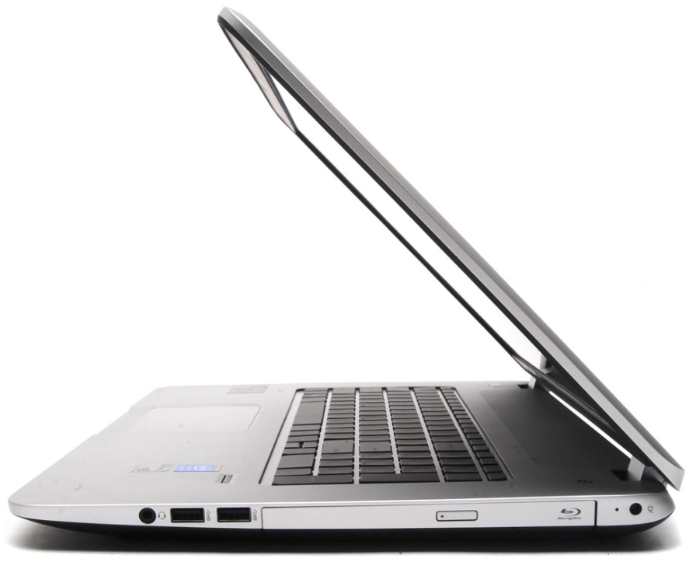
OF A MODERN COMPUTER

Name:
Class:
Teacher:

ICT Components – What do you remember?

An information system is made up of hardware and software.
- Hardware is any device or part of a computer you can physically touch. i.e. processor, input devices, output devices and storage devices
- Software is a set of instructions or program which controls the hardware. i.e. windows XP, MS Word

Input Devices
An input device allows data to be entered into the computer – this can be achieved in a number of different ways:
- Keyboard
- Mouse
- Joystick
- Touch Screen
- Scanner
- Microphone
- Sensor
- Digital Camera

Output Devices
An output device allows processed data (information) to be presented. This can be achieved in a number of different ways:
- Monitor
- Printer
- Speaker
- Plotter
- LEDs (Light Emitting Diodes)

Storage Devices
A storage device allows you to store data to the computer’s internal hard disk or external storage devices for later use such as:
- CDs/DVDs
- Blu-Ray Disks
- Magnetic Tape
- USB Pens/Memory Pens
These devices can be categorised into Optical, Solid State and Magnetic devices.
Now let’s take it to the next level and see what’s under the hood!

Memory Devices
A memory device, such as Random Access Memory (RAM), holds current instructions, programs and data in the short term whilst it is being used by the computer. However, these devices do not actually store the data. This means it is volatile (When the power is switched off, the data held on these devices is lost.
It is then important that data is stored on a storage device so we can retrieve it.

Assessment Questions
Q1. What is hardware?
[1]
Q2. What is an input device?
[1]
Q3. What is an output device?
[1]
Q4. What is a storage device?
[1]
Q5. What type of device is a monitor?
[1]
Q6. What type of device is a scanner?
[1]
Q7. What are the three categories of storage device?
[3]
Q8. What category of storage device is a hard disk drive?
[1]

TOTAL: /10

Homework Worksheet
Write the name of the following devices in the box below each picture and then state whether it is used for input, output or storage. One has been completed for you.
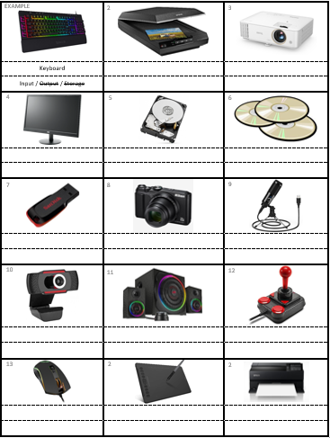
TOTAL: /28
Select one input, one output and one storage device and explain how you would use it in school.
Input Device:
Output Device:
Storage Device:

Under the Hood

Data: Raw facts and Figures with no meaning or context attached. This could be in the form of values and measurements. On other words, it is ambiguous facts and figures. i.e. A+
Information: Data that has been processed. It has been given meaning and added context. It is not open to interpretation. i.e. Joe Bloggs’ blood group is A+.
Compute: The verb ‘to compute’ means to carry out mathematical calculations. Today, with electronic computers everywhere, the term is more commonly defined as the use of computers to solve problems.

To Compute

The word ‘compute’ is derived from the Latin word ‘computare’, which means ‘to count up’, ‘to sum up’, ‘to reckon together’. The Romans certainly did not have computers and ‘to compute’ does not mean to use a computer.
Computing is something that we all do whenever we perform a mathematical calculation.
The electronic computer is not the first device that people have used to help them to compute. For many centuries mathematicians have been inventing tools to help them to carry out calculations with greater speed and accuracy.

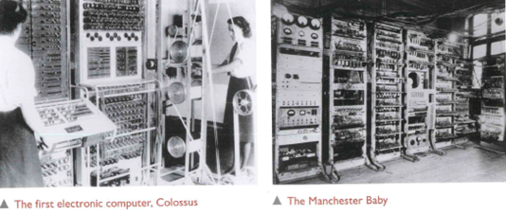
﻿Since prehistoric times and the very earliest civilisations there has been a need to compute in order to solve problems. The ancient Egyptians used mathematics to build their pyramids and the ancient Greeks applied geometry to their study of astronomy. Computing is so important that great mathematicians have always been highly revered.
All over the world they have become well-known historical figures, such as the ancient Greek Pythagoras, Lui Hui from 3rd- century China, Muhammad Al-Khwarizmi from 9th-century Persia and Bhaskara from 12th-century India.
You can find more details about famous mathematicians through time at www.storyofmathematics.com/mathematicians.html

Traditionally we think of computers as the large desktop machines that many of us regularly use at home and at school. However, in recent years computers have become faster and smaller.
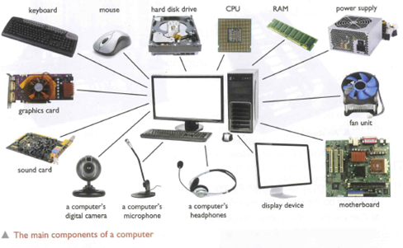
﻿Now look at a Raspberry Pi, the credit-card-sized computer that you can plug into a TV and a keyboard.
It is a capable little device that enables people to explore computing, and to learn how to program in languages like Scratch and Python. It’s capable of doing everything you’d expect a desktop computer to do, from browsing the internet and playing high-definition video, to making spreadsheets, word-processing, and playing games.

What’s more, the Raspberry Pi has the ability to interact with the outside world, and has been used in a wide array of digital maker projects, from music machines and parent detectors to weather stations and tweeting birdhouses with infra-red cameras.

Can you locate the processor, the memory, the storage and the input and output?

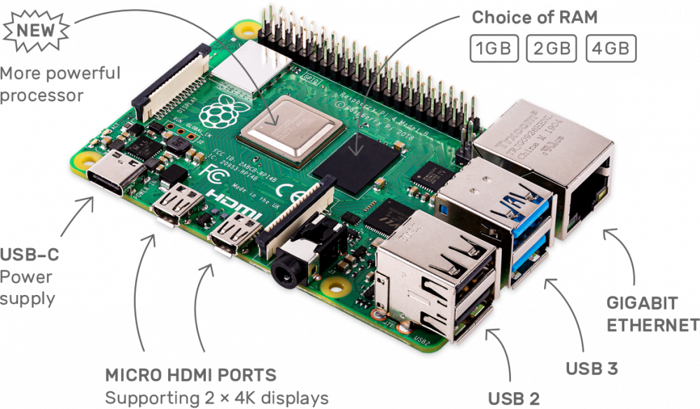

Recap
Information: Once data has been processed and given meaning, it can be termed information. For example, data would be ‘16’ whereas information would be ‘Alex has just turned 16’. It is now clear what the piece of data is relating to.

It is possible to categorise the parts of a computer as input devices, memory, storage devices, processor and output devices.
Key Terms
Input Devices | An input device enables the user to ‘input’ data into a computer i.e. Keyboard/mouse/etc
Memory | This is where a computer keeps the data that has been input, as well as software applications and the results of any processing it has carried out, for the short term. This memory is lost when the computer is off. i.e. RAM
Storage Device | This is where a computer stores files that have been created, as well as software that has been installed, for the longer term. i.e. HDD/Floppy Disk/USB/etc
Processor | The part of a computer that processes data according to the instructions is has been given. It provides the user with information. i.e. CPU/GPU
Output Device | An output device enables the user to receive information from a computer. i.e. Printer/Scanner/plotter/etc

Do you Think Like a Computer?

In Groups - You must write all of the steps to complete making a banana sandwich.
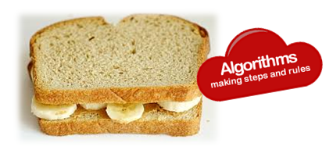
List of Ingredients and Utensils available (Sitting on table top):

Table | Bread | Knife
Banana | Butter | Plate

The Central Processing Unit
The Central Processing unit, or CPU, is sometimes described as the computer’s brain. It is an important part of the computer system and it usually consists of a single integrated circuit (chip). It isn’t as complicated as a human brain though. It thinks more like a function machine, which you might have come across in maths lessons.

Central Processing Unit (CPU): The part of the computer hat interprets and executes instructions.

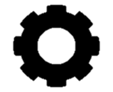
Memory
4
(X 3) + 7
Process
19
INPUT
OUTPUT
VDU
The CPU has to be told what to do with the data. The instructions usually come from software applications, which are also known as ‘computer programs’. In the illustration there are two instructions, ‘multiply by 3’ and ‘add 7’
The CPU has to have some data to process. This is often input using a keyboard or a touch screen. The data is stored in the computer’s memory. In the illustration the number ‘4’ has been entered into the function machine’s memory.
The result of the processing, 19, is sent to an output device, usually a display, monitor or data projector, so that the user knows what it is. Note that the instructions have to be processed in the correct sequence, otherwise the result would be 33.

When a teacher asks you to do something, you listen (fetch), work out what you are being asked to do (decode) and then do it (execute). A CPU works in a similar way. It:
- Fetches the instruction from memory
- Decodes the instruction to find out what processing to do
- Executes the instruction
Fetch
Decode
Execute

A Fetch-Decode-Execute Cycle

Code Breakers
Enigma and the Lorenz machine
During the Second World War vital supplies were sent to Britain from the United States of America, but Nazi submarines (U-boats) were sinking large numbers of the ships bringing these supplies across the Atlantic. Winston Churchill understood that intelligence was crucial if Britain and its allies were to win the Second World War, and he put his faith in the team of code breakers at Bletchley Park. Their task was to decrypt Nazi communications. The Nazis were enciphering their messages using the Enigma machine and its successor, the Lorenz machine. If the Allies were able to break the codes, they could keep one step ahead of the Nazis.
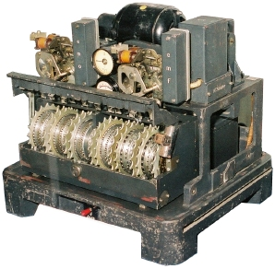
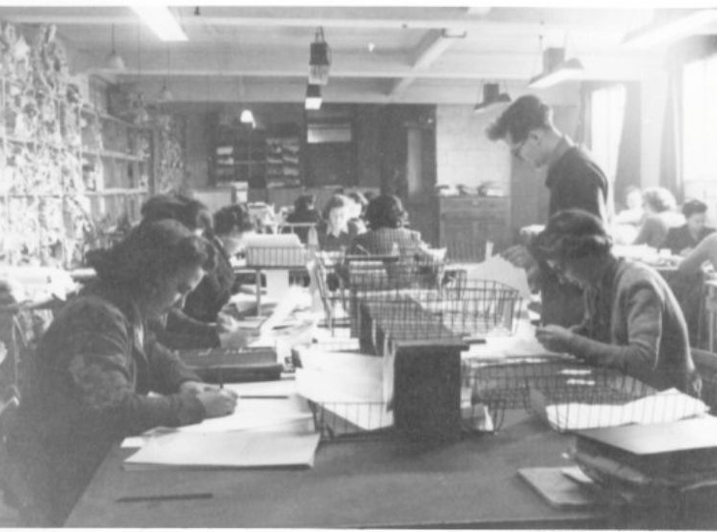
The Nazis used the Lorenz Cipher machine at they believed it to be the most secure way of sending messages at the time.
Some of the code-breaking team at Bletchley Park

Colossus
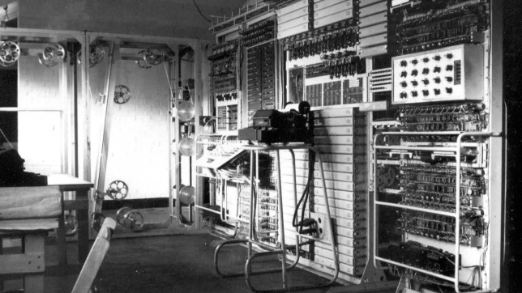
Code breaking requires vast numbers of computations to be carried out extremely quickly. The team at Bletchley Park were working against the clock. Alan Turing, the mathematician who led the team, knew that humans were just too slow at performing the required volume of calculations, so the code breakers built a computer, known as Colossus (see the photograph on page 2), to speed things up. Colossus decrypted codes generated by the Lorenz Machine by carrying out complex analysis on the messages that were intercepted. Colossus could read 5000 characters per second. This meant that the analysis could be carried out in hours, rather than weeks. In a sense, Colossus was a function machine because it was programmed to perform just one task.
It took the enciphered input, processed it and, after many repetitions, produced the deciphered output.
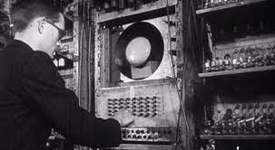
The Manchester Baby
A computer uses stored programs and must have writeable memory to store, load and run them. The Manchester Baby, developed shortly after the Second World War, was one of the first programmable computers. It was the ability to store and run programs that turned the special purpose computer, or function machine, into at general purpose computer.

The Decimal Number System
At school, you learn how to use the decimal number system – that is units, tens, hundreds and thousands. The decimal number system is also known as base 10 because it uses ten different numbers – 0, 1, 2, 3, 4, 5, 6, 7, 8, 9 - to make an infinite number of combinations.
Computers are electronic devices that use just two data values, 0 and 1. They can tell the difference between a high voltage and a low voltage, so we use high voltage to represent 1 and a low voltage to represent 0. Using two values, 1 and 0, to represent numbers is known as binary or base 2. All data in a computer must be in binary, so anything that is to be processed or transferred between computers, including all words, sounds and images, must first be converted into a series of 1s and 0s.
Decimal: the system that is normally used for counting and computation. It uses ten digits, and can be referred to as base 10.
Binary: A number system which uses two digits, 0 and 1. All electronic computation is carried out using the binary system. The binary number system is also called base 2.

Circuit Semaphore

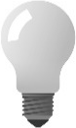
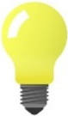
Imagine an electronic circuit with three lights, each controlled by its own switch. You can switch the lights on in many different patterns. Now imagine that each pattern represents a number, and each number relates to a message in a code book.
Challenge!
How many different combinations can you have with…
- One Light?
- Two Lights?
- Three Lights?
Using this information, how many do you think you could make with 4 light bulbs?

Binary Research
- Copy and extend the table below as required. Complete the cells for all the different binary combinations you can make. The first few cells have been completed for you.
1 Bit | 2 Bits | 3 Bits | 4 Bits
0 | 00 | 000
1 | 01 | 001

- What pattern can you spot when working out the largest number with a given number of bits?
- Research the invention in 1836 by a man called Samuel. Hint: This is related to this binary idea of Dot-Dash.

Bits and Bytes
Computers use electrical circuits to process data. These circuits require the data to be in a digital form as a string of binary digits, or 1s and 0s. A bit is the name given to one binary digit and is the smallest piece of data that a computer can process.
All the data stored on, and processed by, a computer is simply a long series of bits. To give an idea of scale, a single letter of text, for example the letter ‘a’, is represented by eight bits.
You have seen how a computer represents letters and numbers. Sound is digitised by sampling it at intervals, and images are digitised by representing coloured dots with binary numbers.

Kilobytes and Megabytes
Many people generate computer files giving little thought to what these files consist of and how they are stored. The terms ’kilobyte’ and ‘megabyte’ are used to describe the size of the storage space inside a computer; the amount of memory available to store data for use when processing and to store the output of the processing in the form of files. The prefix ‘kilo’ means thousand and ‘mega’ means million, so a ‘megabyte’ is one million bytes.
Unit | Size
Bit | A binary digit, 1 or 0
Nibble | 4 bits
Byte | 8 bits
Kilobyte | 1024 bytes
Megabyte | 1024 kB
Gigabyte | 1024 MB
Terabyte | 1024 GB
Petabyte | 1024 TB


Using your understanding of bits and bytes, convert the following values, which represent file sizes, into bits. Show your working:
- 7kB
- 29 kB
- 279 kB
- 1 MB
- 2MB

